**Universal Health Insurance**

* **GUI:**

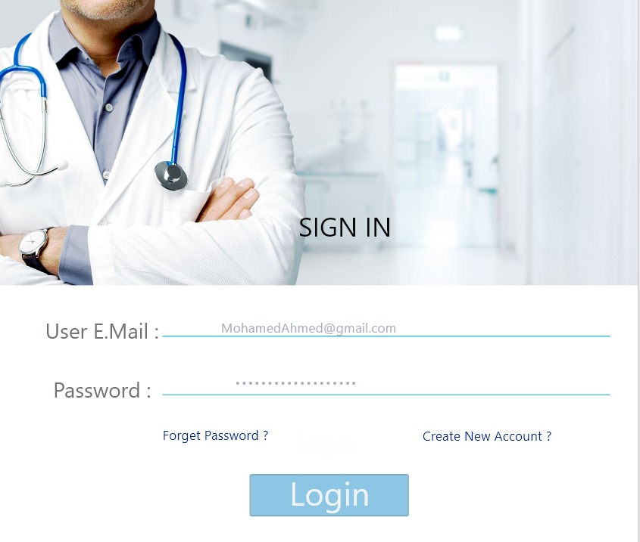

Description:-

* **Registration Form:**

Type: (Form).

Description: It is a form that allows the patient to register into the system by entering the e-mail and the password.

It allows him to enter to the system if this Data is correct or you get new password if he forgot his password.

It allows the patient to create account if he is new comer.

Component: It contains two edit text for registration to system, two links and one button.

One of the edit texts is for email of user and the other is for password of user.

One of the links is for forgotten password if the user can’t remember its password and the other for creating the account if the user enter the system for first time.

The button for login and the user will enter on it if he filled the two edit box.

Entities: (family father and member).

Note: An error message will appear to the user if he doesn’t fill all the edit texts in the form.

* **User Email:**

Type: (Edit Text).

Description: It allows the user to enter his exist email and the email should contain @ --- .com and this email should connect to user ID.

Note: An error message will appear to the user if its email doesn’t contain @ or the user enters incorrect email that doesn’t connect to the database of organization.

* **User Password:**

Type: (Edit Text).

Description: the user should enter his password and it contains user password and it should be at least b8 characters and contain capital case, number and “_”.

Note: An error message will appear to the user if its password doesn’t contain conditions required password.

* **Create New Account:**

Type: (Link).

Description: this link that allows the patient to create new account if he doesn’t have any account to enter to the system.

When the user clicks on this link, it will lead him to the create account page which allows him to enter all information about him to create a new account in the system.

* **Forget Password:**

Type: (Link).

Description: this link that allows the patient to create new password if he forgot his password.

When the user clicks on this link, it will lead him to the create password form which validates from the user ID and create new password.

Note: an error message will appear if the user enter incorrect ID.

* **Login:**

Type: (Button).

Description: this item that allows the patient to enter to the system if the data he has entered is correct.

Note: An error message will appear to the user if he doesn’t fill all the edit texts in the registration form.

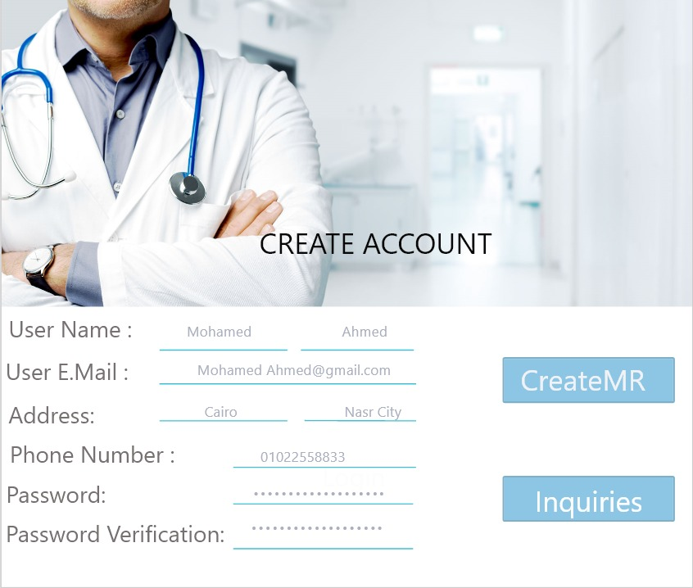

Description:-

* **Create Account:**

Type: (Form).

Description: It is a form that allows the patient to create new account by adding all information about himself and choose the appropriated password.

Component: It contains six edit text for creating new account to system and two button.

First of the edit texts is for user name (father), the second is for phone number, the third is for e-mail, the forth is for password, the fifth is for password verification and the last is for address.

One of the buttons is for creating the medical record and the other for inquires.

Entities: (family father and member)

Note: An error message will appear to the user if he doesn’t fill all the edit texts in the form.

* **User Name (Father):**

Type: (Edit Text).

Description: It should contain the first name and last name of the father of family that will sign up to the universal health insurance.

First letter of names should be capital and an error message will appear to the user if he doesn’t do it.

Note: An error message will appear if he doesn’t do it.

* **Phone Number:**

Type: (Edit Text).

Description: It should be filled with user phone number and it should be 11 number.

Note: An error message will appear if the phone number be less than 11 number.

* **E-mail:**

Type: (Edit Text)

Description: It allows the user to enter his exist email and the email should contain @ --- .com and this email should connect to user ID.

Note: An error message will appear to the user if its email doesn’t contain @ or the user enters incorrect email that doesn’t connect to the database of organization.

* **Password:**

Type: (Edit Text).

Description: the user should enter his password and it contains user password and it should be at least b8 characters and contain capital case, number and “_”.

Note: An error message will appear to the user if its password doesn’t contain conditions required password.

* **Password Verification:**

Type: (Edit Text).

Description: the user fills it with entering a password again to verify it.

Note: An error will appear if the user enters the verifying password incorrectly.

* **Address:**

Type: (Edit Text).

Description: the user should consists of letters and be in details.

Note: An error message will appear if the user doesn’t do it.

* **Create medical record:**

Type: (Button).

Description: this item that will deliver to the form allowing father from create medical record of his family.

* **Inquiries:**

Type: (Button).

Description: this item that will deliver to the form of all information about the system.



Description:-

* **Create Medical Record:**

Type: (Form).

Description: It is a form that father uses it to sign up family to the system and it consists from several text boxes and a number of buttons, one of them is for paying subscription and the others will be by the number of members of the family and it will determine according to the number of family assigned by the father.

Component: It contains six edit text for creating new account to system and a button.

First of the edit texts is for father full name, the second is for number of the family members, the third is for phone number, the forth is for the family medical record number, the fifth is for date of the creation and the last is for name of the family doctor.

One of the buttons is for paying the subscription.

Entities: (family father and member).

Note: An error message will appear to the user if he doesn’t fill all the text boxes in the form.

* **Father Full Name:**

Type: (Edit Text).

Description: It should contain the first name and last name of the father of family that will sign up to the universal health insurance.

First letter of names should be capital and an error message will appear to the user if he doesn’t do it.

Note: An error message will appear if he doesn’t do it.

* **Number of Family Members:**

Type: (Edit Text).

Description: It should be filled with number of the family members entered by father.

It should be a number.

Note: An error message will appear to the user if he doesn’t do it.

* **Phone Number:**

Type: (Edit Text).

Description: It should be filled with user phone number and it should be 11 number.

Note: An error message will appear if the phone number be less than 11 number.

* **Family Medical Record Number:**

Type: (Edit Text).

Description: It should be filled with number by the organization that assigns it to each family.

* **Date of Creation:**

Type: (Edit Text).

Description: It should be filled with number by the organization in the same date that the father assigns to this form.

* **Name of Doctor:**

Type: (Edit Text).

Description: It should be filled with the name of family doctor that the organization assigned to each family.

* **Pay Subscription:**

Type: (Button).

Description: It is an item that when the user clicks on it, it will driver him to the accounting department to pay the subscription and join in the system.

**Number of Buttons that will driver to medical record of the member that have the same number existed in the button.**

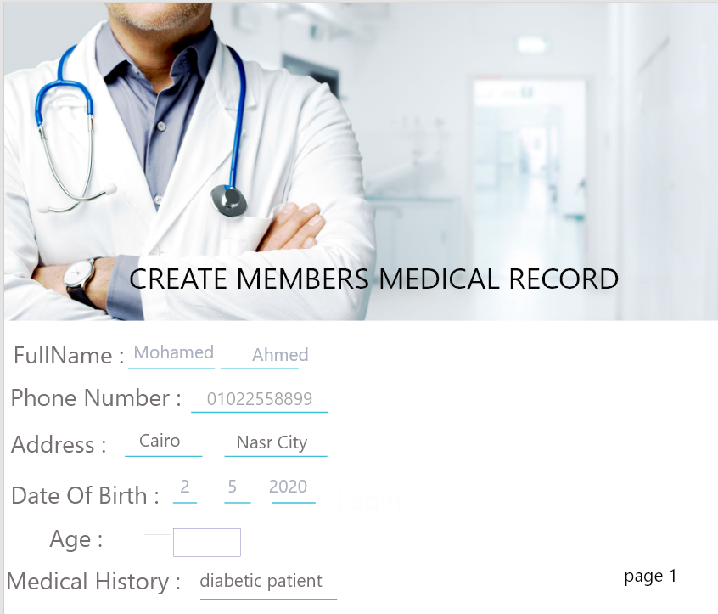

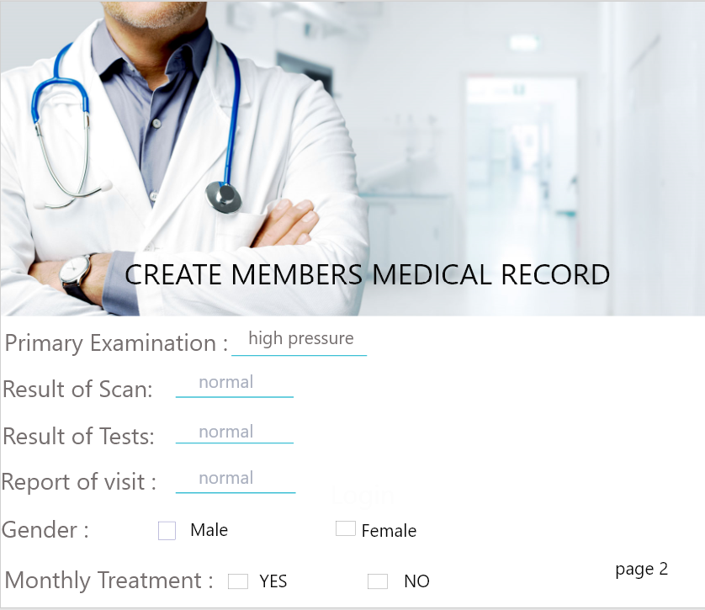

Description:-

* **Medical Record (n):**

Type: (Form).

Description: it is the form of the member that chose its number from create Medical record or the clerk entered its number to the system.

Component: It contains ten edit texts for creating new account to system and three check box.

First of the edit texts is for full name, the second is for phone number, the third is for address, the forth is for the date of birth, the fifth is for age of the patient, the sixth is for medical history, the seventh is for primary examination, the eigthth is for result of the scan, the ninth is for the result of the tests and the last is for the report of each visit.

One of the check boxes is for gender, the second is for the surgery and the last is for monthly treatment.

Entities: (family father, member and adminstrator).

Note: An error message will appear to the user if he doesn’t fill all the text boxes in the form.

* **Full Name:**

Type: (Edit Text).

Description: It should contain the first name and last name of the father of family that will sign up to the universal health insurance.

First letter of names should be capital and an error message will appear to the user if he doesn’t do it.

Note: An error message will appear if he doesn’t do it.

* **Phone Number:**

Type: (Edit Text).

Description: It should be filled with user phone number and it should be 11 number.

Note: An error message will appear if the phone number be less than 11 number.

* **Address:**

Type: (Edit Text).

Description: the user should consists of letters and be in details.

Note: An error message will appear if the user doesn’t do it.

* **Date of Birth:**

Type: (Edit Text).

Description: It is an edit text that should be filled with user birth date and it should be numbers.

Note: An error message will appear if the user enters letters.

* **Age of Patient:**

Type: (Edit Text).

Description: It is an edit text filled with age of each member of family.

It should be a number.

Note: An error message will appear to the user if he doesn’t do it.

* **Medical History:**

Type: (Edit Text).

Description: It is an edit text filled with the diseases of patient that he had and surgeries he done over his life.

* **Primary Examination:**

Type: (Edit Text).

Description: It is an edit text filled by the doctor family that contains patient blood pressure, diabetes and an electrocardiogram.

* **Result of Scans:**

Type: (Edit Text).

Description: It is an edit text filled with the result of scans asked by the family doctor that patient done it in the radiology department.

* **Result of Tests:**

Type: (Edit Text).

Description: It is an edit text filled with the result of tests asked by the family doctor that patient done it in the test department.

* **Report of each Visit:**

Type: (Edit Text).

Description: It is an edit text filled with report of specialist about patient case in each visit he came to hospital and its date.

* **Gender:**

Type: (Check box).

Description: It is a selected item that contains two options male or female and the user should determine his gender.

* **Surgery:**

Type: (Check box).

Description: It is a check box that the patient marks on it when the patient did any surgery.

* **Monthly Treatment:**

Type: (Check box).

Description: It is a check box that the patient marks on it when the patient had any treatment monthly.

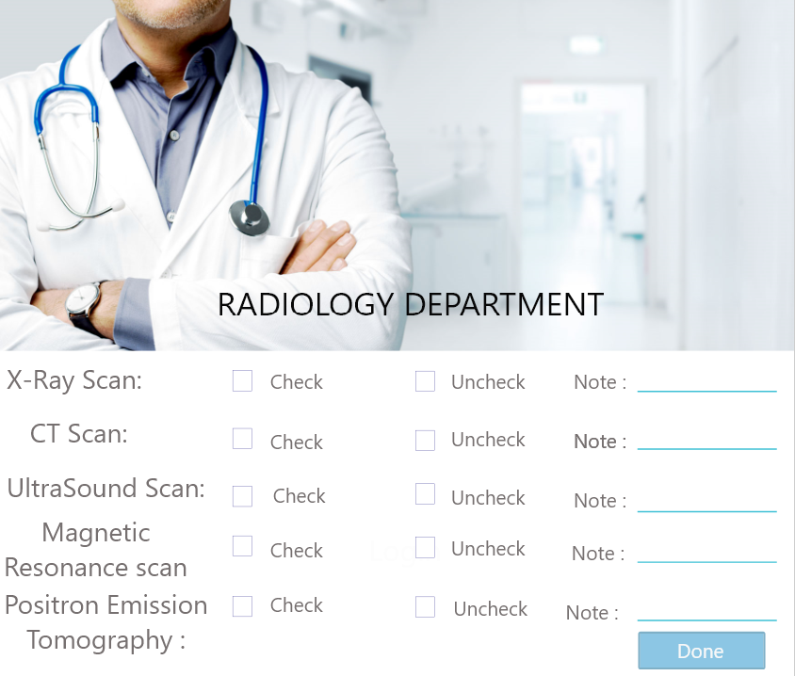

Description:-

* **Radiology Department:**

Type: (Form).

Description: It is the form that consists of all scans types as view text and the patient select if his scan is normal or not and will appear in the bottom note of the scan, he has problem in it.

Component: It contains five text views.

Entities: (family father, member, radiologist and the doctor).

* **X-ray Scan:**

Type: It is a view text.

Description: it has two empty squares one for normal and one for un normal and the patient will mark next of one of these squares according to his case.

* **CT Scan:**

Type: It is a view text.

Description: it has two empty squares one for normal and one for un normal and the patient will mark next of one of these squares according to his case.

* **Ultrasound Scan:**

Type: It is a view text.

Description: it has two empty squares one for normal and one for un normal and the patient will mark next of one of these squares according to his case.

* **Magnetic Resonance Scan:**

Type: It is a view text.

Description: it has two empty squares one for normal and one for un normal and the patient will mark next of one of these squares according to his case.

* **Positron Emission Tomography:**

Type: It is a view text.

Description: it has two empty squares one for normal and one for un normal and the patient will mark next of one of these squares according to his case.

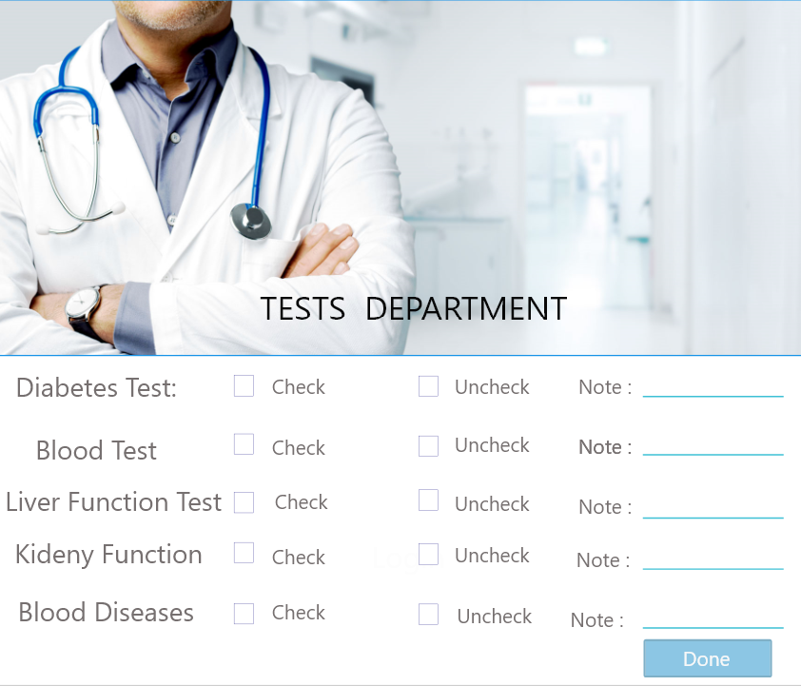

Description:-

* **Test Department:**

Type: (Form).

Description: It is the form that consists of all tests types as view text and the patient select if his test is normal or not and will appear in the bottom note of the test, he has problem in it.

Component: It contains seven text views.

Entities: (family father, member, tester and the doctor).

* **Diabetes Tests:**

Type: It is a view text.

Description: it has two empty squares one for normal and one for un normal and the patient will mark next of one of these squares according to his case.

* **Blood Lipids:**

Type: It is a view text.

Description: it has two empty squares one for normal and one for un normal and the patient will mark next of one of these squares according to his case

* **Liver Function Tests:**

Type: It is a view text.

Description: it has two empty squares one for normal and one for un normal and the patient will mark next of one of these squares according to his case.

* **Tests of Kidney Function:**

Type: It is a view text.

Description: it has two empty squares one for normal and one for un normal and the patient will mark next of one of these squares according to his case.

* **Blood Fluidity Tests:**

Type: It is a view text.

Description: it has two empty squares one for normal and one for un normal and the patient will mark next of one of these squares according to his case.

* **Blood Diseases:**

Type: It is a view text.

Description: it has two empty squares one for normal and one for un normal and the patient will mark next of one of these squares according to his case.

* **Hormones:**

Type: It is a view text.

Description: it has two empty squares one for normal and one for un normal and the patient will mark next of one of these squares according to his case.

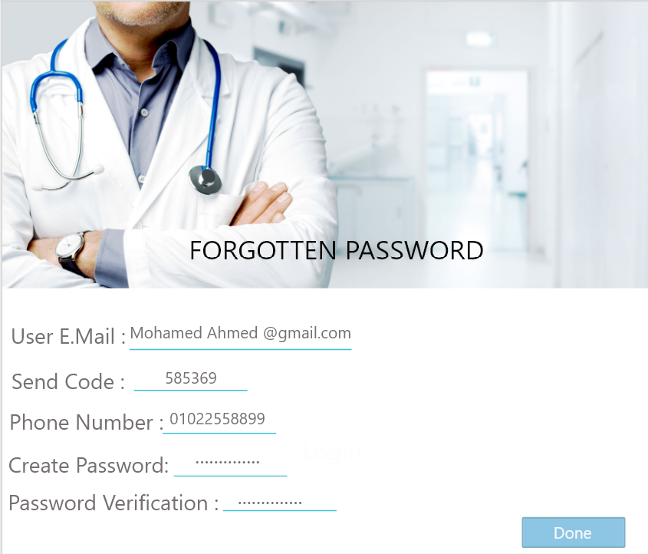

Description:-

* **Forgotten Password:**

Type: (Form).

Description: It is a form to if the patient forgets his password when he logs in the system, he clicks in the link of forgotten password and it will lead him to this form.

Component: It contains five edit texts.

Entities: (member and adminstrator).

* **Email:**

Type: (Edit Text)

Description: It allows the user to enter his exist email and the email should contain @ --- .com and this email should connect to user ID.

Note: An error message will appear to the user if its email doesn’t contain @ or the user enters incorrect email that doesn’t connect to the database of organization.

* **Phone Number:**

Type: (Edit Text).

Description: It should be filled with user phone number and it should be 11 number.

Note: An error message will appear if the phone number be less than 11 number.

* **Code:**

Type: (Edit Text).

Description: It is an edit text that the user should fill it with code that the system sent to his phone number.

* **Create Password:**

Type: (Edit Text).

Description: the user should enter his password and it contains user password and it should be at least b8 characters and contain capital case, number and “_”.

Note: An error message will appear to the user if its password doesn’t contain conditions required password.

* **Password Verification:**

Type: (Edit Text).

Description: the user fills it with entering a password again to verify it.

Note: An error will appear if the user enters the verifying password incorrectly.



Description:-

* **Home page:**

Type: (Form).

Description: After creation of medical record of new families or login by registered family’s patient go to home page that contain five items.

Component: It contains five buttons.

Entities: (member, adminstrator and the doctor).

* **Enquiry:**

Type: (Button).

Description: this item allow patient to enter to system to know more data about it or to search about anything he want to know about system, this item transfer user to another form that contain search items and system data.

* **Medical record page:**

Type: (Button).

Description: when this item clicked allow patient to go to a form that contain patient medical record (all data about patient that has been entered to it by user or by family doctor and results of radiation and tests).

* **Accounts:**

Type: (Button).

Description: when this item clicked allow patient to go to a form that contain all data about patient accounts (subscriptions, treatment cost, sale rate and surgeries cost) that has been paid or that need to be paid by patient.

* **Take appointment:**

Type: (Button).

Description this button allow patient to take appointment from administrator to check by choosing department, doctor and hospital and assign date and time to check.

* **Logout:**

Type: (Button).

Description this button allow patient to logout after doing examination and required tests and radiations and take medicine and ensure that he has paid his subscriptions and visit has been recorded by family doctor and added to medical record.

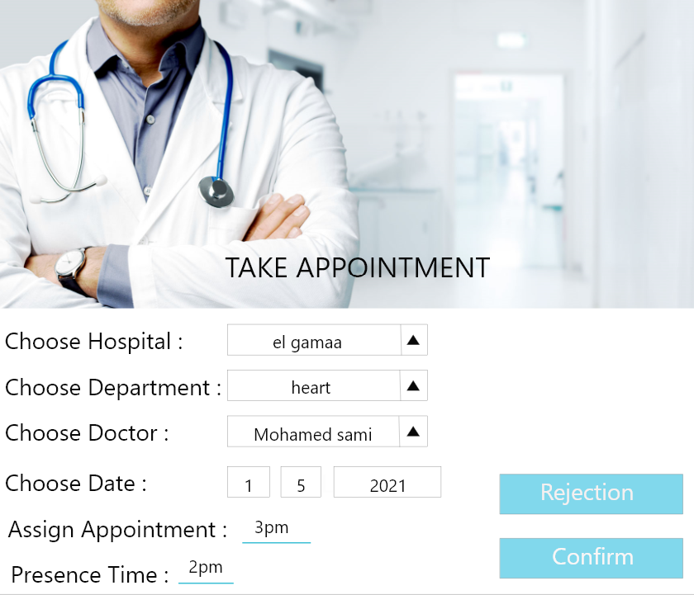

Description:-

* **Take Appointment:**

Type: (Form).

Description: If patient select item of take appointment he will enter to this form which allow him to take appointment to do examination this form contain main items that patient must complete to take appointment.

Components: it consists of four selected items, two text views and two button.

Entities: (member, doctor and adminstrator).

* **Choose hospital:**

Type (select item).

Description: this item allow patient to appropriate hospital that he want to do his examination in this selection based in (nearest hospital to user, best hospital performance, hospital that offer many services to user and hospital that connect with database).

* **Choose department:**

Type (select item).

Description: patient should select wanted department that he wants to do examination in it .it selects depending on (patient case, patient disease and patient complain).

* **Choose Doctor:**

Type (select item).

Description: this item allow user to choose a doctor that exists in selected hospital and selected department from list of doctors that are available this selection based on(best doctor in this branch , best rate doctor by other patient and doctor that is exist in wanted day to examine.

* **Choose Date:**

Type (select item).

Description: this button allow patient to choose date that he want to do his examination in this date written by selected item of (day - month – year ) and according to this date system show available doctor in this day.

* **Assign appointment:**

Type (Text View).

Description: after choosing wanted hospital, wanted department, wanted doctor and appropriate date. System assigns an appointment for each patient this appointment will presented in form of hour that he will do examination in it.

* **Assign time he must be in the hospital:**

Type (Text View).

Description: the system must inform user of time that he must be present in hospital this item reduces waiting time in the hospital and decrease overcrowding and boring from long waiting time.

* **Confirm:**

Type (Button).

Description: after completing the previous data (hospital, department, doctor, date and assign appointment and present time). patient should confirm if this appointment is suitable for him or not.

* **Rejection:**

Type (Button).

Description: after completing the previous data (hospital, department, doctor, date and assign appointment and present time) .assigned appointment may be unsuitable to user and he press this key to reject this appointment.

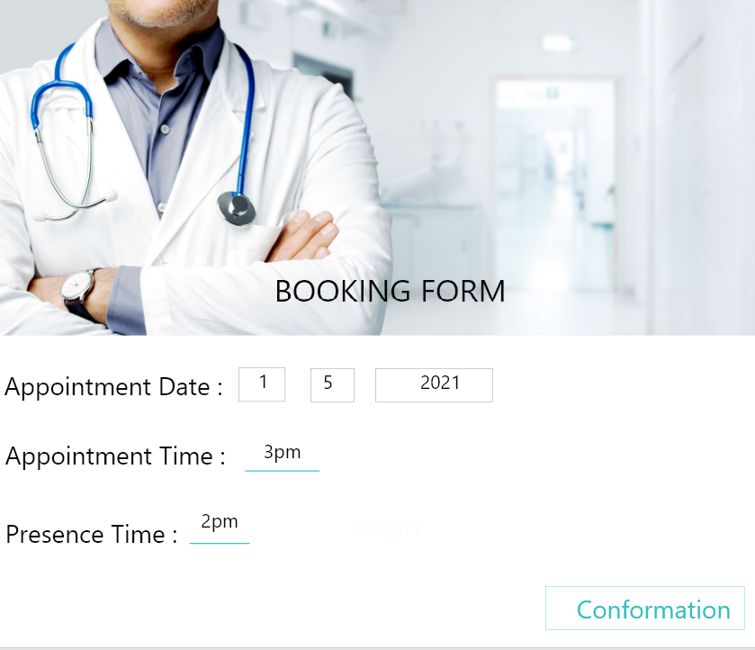

Description:-

* **Booking form:**

Type (Form).

Description: after confirmation of appointment that has been assigned by system this booking is added to system database and user should inform of it this form function is to form patient that his appointment has been recorded this form contain two items.

Components: it consists of two text views.

Entities: (member, adminstrator and doctor).

* **Appointment Date:**

Type: (text view).

Description: this item show date that has been assigned to patient and that has been added to system that the patient should follow.

Note: that this massage is a confirmation message that the patient should follow

* **Appointment Time:**

Type: (text view).

Description: this item show time that has been assigned to patient and that has been added to system that the patient should follow

Note: that this massage is a confirmation message that the patient should follow

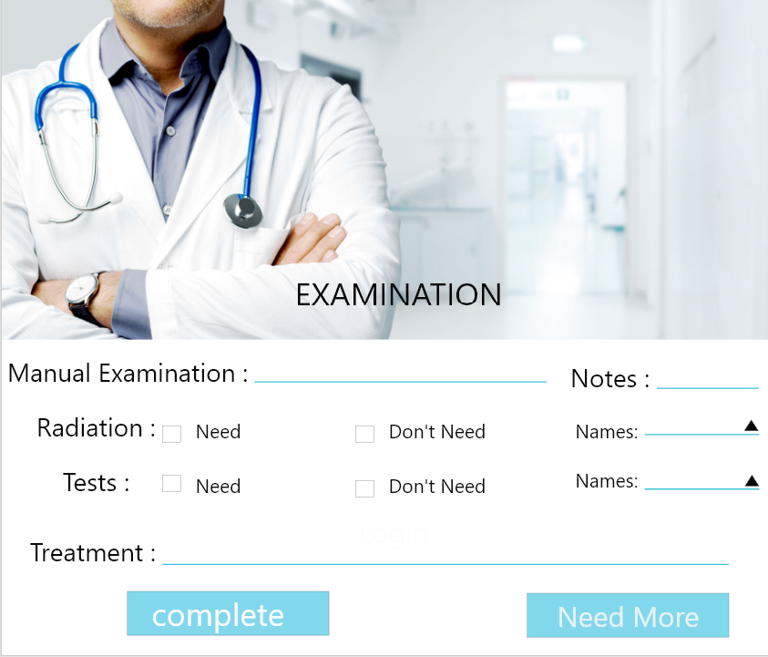

Description:-

* **Examination:**

Type: (Form).

Description: this form includes examination that must be done by specialist. This form includes many processes and data rut should collect about patient and determine by specialist.

Components: it consists of one link, two text views, two check boxes and two buttons .

Entities: (member, adminstrator and doctor).

* **Link of Medical Record:**

Type: (link).

Description: specialist should see medical record of patient during examination to know medical history of patient. (if patient has chronic diseases, patient take monthly treatment, patient has done a surgery and any unmoral data about patient).

* **Result of manual examination:**

Type: (text view).

Description: specialist should do a manual examination in the patient and the result of this examination added to this item to be transferred to medical record with the data about this visit and to determine wanted tests and radiation that patient must do and forgive him appropriate medicine.

* **Note of examination:**

Type: (button).

Description: after examination specialist should be take notes if this is unmoral things and these notes should be added to this item.

* **Radiation:**

Type: (check box).

Description: after examination specialist may need to report some radiations that patient must do in radiation department and see this result to determine case of patient.

* **Tests:**

Type: (check box).

Description: after examination specialist may need to report some tests that patient must do in tests department and see this result to determine case of patient.

* **Treatment:**

Type: (text view).

Description: after examination complement specialist should give patient appropriate medicine this item show all names of treatment that doctor gives to patient .

* **Complete:**

Type: (button).

Description: if examination has been completed and doctor has no longer require anything and treatment has been assign patient click this button to go to pharmacy to take medicine and complete that accounts requirement he discharge and visit recorded to his medical record.

* **Need more examinations:**

Type: (button).

Description: if examination has not been completed and doctor require other things such as (test and radiation) and patient may need a surgery patient click this button to go to this departments to do the requirements and do required surgeries.

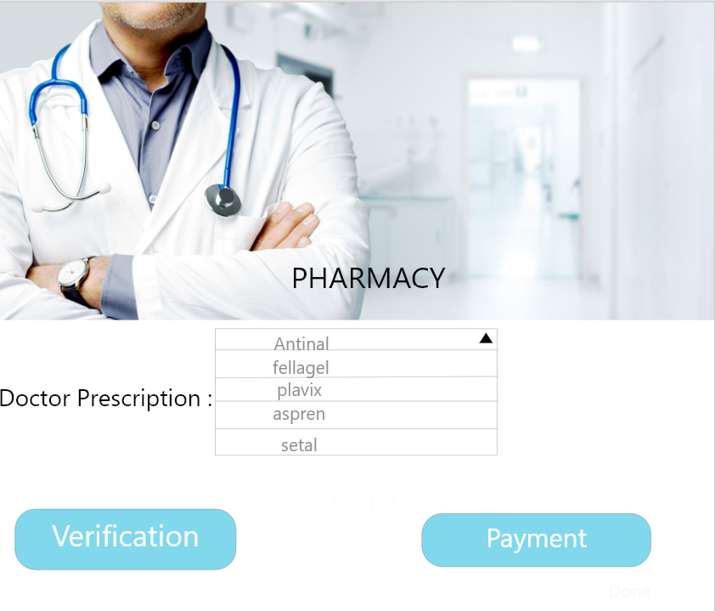

Description:-

* **Pharmacy:**

Type: (form).

Description: doctor gives patient number of treatments. Patient go to pharmacy to takes these medicines and pay these costs in accounts.

Components: it consists of one text views and two buttons.

Entities: (member, pharmacist and doctor).

* **Doctor prescriptions:**

Type: (text view).

Description: pharmacist should give doctor paid treatments. Patient go to pharmacy to takes these medicines.

* **Verification:**

Type: (button).

Description: this button checks if patient has been taken the required treatment that has been written by patient .and all medicines are available.

* **Pay price of medicine:**

Type: (button).

Description: patient should pay the price of the medicines that he has been taken from pharmacy in the accounts.



Description:-

* **Need more:**

Type: (Form).

Description: this form contains addition requirement that doctor need patient to do to accurate examination if patient case require this and to do surgery if required.

Components: it consists of three button.

Entities: (member, radiologist, tester and doctor).

* **Radiations:**

Type: (Button).

Description: this item contains addition radiations requirement that doctor need patient to do to accurate examination if patient case require this and to do surgery if required.

* **Tests:**

Type: (Button).

Description: this item contains addition tests requirement that doctor need patient to do to accurate examination if patient case require this and to do surgery if required.

* **Surgery:**

Type: (Button).

Description: this item contains if doctor that patient case requires to do a surgery this item will lead patient to surgery form.

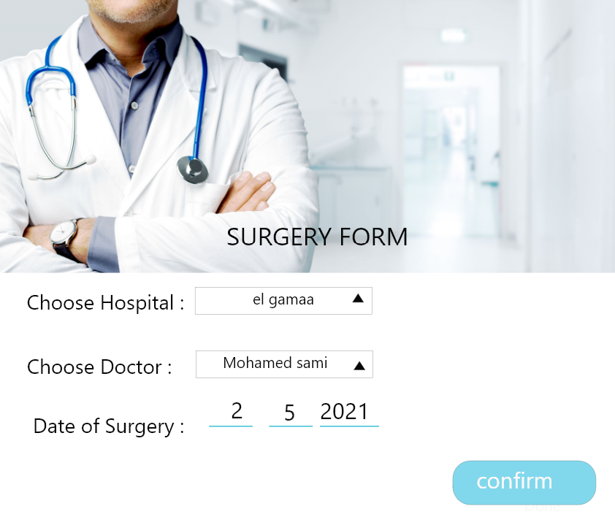

Description:-

* **Surgery Form:**

Type: (Form).

Description: this form contains surgery that patient should do and patient allowed to choose hospital and know date that he will do in it.

Components: it consists of two edit texts, one text view and button.

Entities: (member and doctor).

* **Choose hospital:**

Type: (edit text).

Description: this item allow patient to appropriate hospital that he want to do his surgery in this selection based in (nearest hospital to user, best hospital performance, hospital that offer many services to user and hospital that connect with database)

* **Date of surgery:**

Type: (edit text).

Description: this button allow patient to choose date that he wants to do his surgery in this date written by selected item of (day/month/year) and according to this date system show time of it.

* **Doctor:**

Type: (text view).

Description: this item shows the doctor that will do this surgery, the system add doctor name to database of doctor.

* **Confirm:**

Type: (button).

Description: if patient accepts all the item in the surgery form, he click this button to go to accounts to pay the cost of surgery.



Description:-

* **Confirmation of surgery:**

Type: (Form).

Description: in this form patient complete items that are related to surgery.

After patient accepts all the item in the surgery form, he click this button to go to accounts to pay the cost of surgery.

* **Pay price of surgery:**

Type (text view)

Description patient should pay the price of the surgery that he has been done in the accounts to complete this process in medical record and database.

* **Discount:**

Type (text view)

Description patient should take a discount according to his category in the price of the surgery that he has been done.

* **Confirm:**

Type (button)

Description if patient accepts all the item in the surgery and complete all financial data. He clicks this button to go to accounts to pay the cost of surgery.

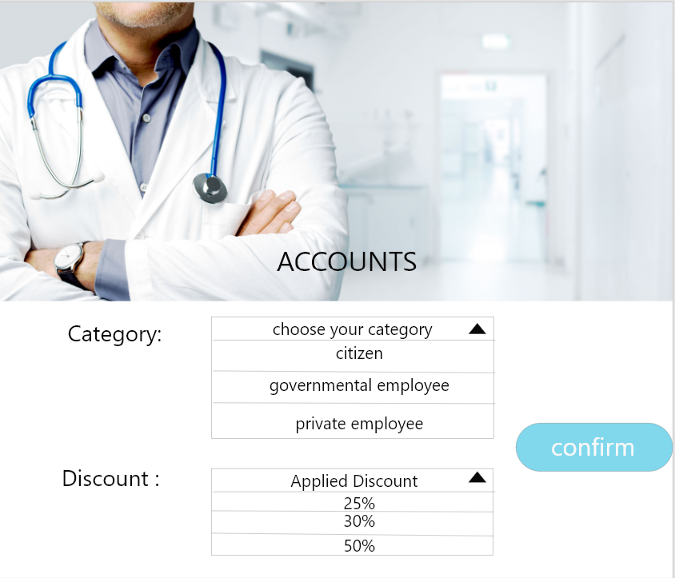



Description:-

* **Accounts:**

Type: (Form).

Description: patient examination, take medicine radiation, tests, surgery and subscription should be paid in this department and add the result of this paid to patient medical record.

Components: it consists of one edit text, 13 text view and two buttons.

Entities: (member and accountant).

* **Category:**

Type: (edit text).

Description: include the branch in the country that patient belongs to it to apply the discount according to this branch.

* **Confirm:**

Type: (button).

Description: after entering patient branch to set applied discount he should click in this button to confirm this data.

* **Discount:**

Type: (text view).

Description: apply the discount according to his branch in the country that patient belongs to it.

* **Confirm:**

Type: (button).

Description: after taking discount according to his branch in the country. He should click in this button to confirm this data.



Description:-

* **Medicine type:**

Type: (text view).

Description: after examination doctor give patient a set of medicines and he take them from pharmacy and this medicine transfer automatically to account for paying.

* **Price of medicine:**

Type: (text view).

Description: the price of the medicines that he has been taken from pharmacy are added to this item.

* **Discount:**

Type: (text view).

Description: apply the discount according to his branch in the country that patient belongs to it.

* **Applying Discount:**

Type: (text view).

Description: apply the discount according to his branch in the country that patient belongs to it in the cost of the medicine that he has taken from pharmacy.

* **Finally cost:**

Type: (text view).

Description: after applying the discount according to his branch in the country that patient belongs to it in the cost of the medicine that he has taken from pharmacy the final result will appear here.



Description:-

* **Surgery type:**

Type: (text view).

Description: according to surgery type that is written in the surgery form is transferring automatically to account for paying.

* **Price of surgery:**

Type: (text view).

Description: the price of the surgery that he has been done by the doctor is added to this item.

* **Discount:**

Type: (text view).

Description: apply the discount according to his branch in the country that patient belongs to it.

* **Applying Discount:**

Type: (text view).

Description: apply the discount according to his branch in the country that patient belongs to it in the cost of the surgery that he does.

* **Finally cost:**

Type: (text view).

Description: after applying the discount according to his branch in the country that patient belongs to it in the cost of the surgery that he has does. the final result will appear here.

* **Confirm:**

Type: (button).

Description: after paying costs. he should click in this button to confirm this data.